INERTIA
Sir Isaac Newton (1642-1727) is the second most famous scientist who ever lived. He studied the motion of objects and discovered the 'laws of motion'. The law of inertia is often referred to as Newton's first law. The law of Inertia states that an object will maintain its velocity until an external force acts on it.
Another, simpler way of saying this law is that objects only change the way they move when a force acts directly on them.
A simple example is - a ball at rest (still) will only move if an external force acts on it. A more complicated example is - a car that hits a barrier has an external force exerted on it by the barrier. This force is so strong that it stops the car. However anything loose inside the car (including people) will continue to move forward until something also exerts an external stopping force on it. If there is nothing else in front of them, people in the car will smash into the windscreen. Seatbelts were invented to provide a stopping force for passengers – as opposed to the windshield of the car!
All objects have inertia, and the greater the mass (heavier) of an object, the more inertia it has. On the earth's surface, gravity and friction often provide a force which opposing motion, and slows things down. For example, a rolling bicycle slows and stops on earth due to the (external) forces of friction (with the road) and the air. A bicycle in space would continue moving forever as there is no air resistance and no friction from a road (a free ride… but in space you’d be dead anyway).
Complete these by typing into the space (they will be your notes on INERTIA)
- The tendency of an object to remain in its present state of motion unless acted upon by an external force is called the Law of __________
- A moving object will keep ___________ in the ________ direction unless acted on by an external ________
- A heavy object will have ___________ inertia than a light object.
- Objects at rest tend to stay at __________ unless acted on by an _________ force.
Examples
- An object sliding along a _________ surface like ice continues to move at the same speed until it strikes the wall or someone ___________it.
- In a bus which suddenly ___________ you appear to fall backwards because there is no ________ _________ being directly applied to you (except your feet).
- When a car stops suddenly, a person continues to __________________ until their seatbelt applies an __________ ________ on them to stop them hitting the windscreen.
- A thrown ball will continue to _______ until it ________ something

Pick any two pictures and in the space below, explain what is happening.
You should use the terms inertia, velocity, external force.

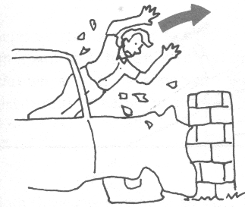
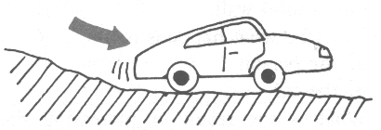
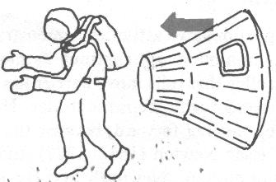
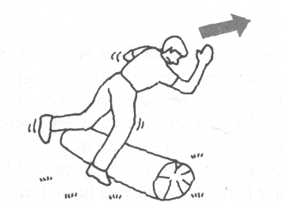
The driver of a car is thrown through the windscreen when the car crashes
A car rolling along a rough road comes to rest (stop) of its own accord.
An astronaut steps out of his spacecraft
while in orbit, and keeps drifting away from his spacecraft.

If walking and your foot hits the log, you fall forward.

